**Software Requirements**

**Specification**

**for**

**HomeCarePro System**

**Version 1.2 approved**

**Prepared by:**

**Hamdan Ali 21I - 0754**

**Omais Afzal 21I - 1369**

**Ahsan Wasim 21I - 0440**

**FAST NUCES**

**March 1, 2024**

**Table of Contents**

**1. Introduction** **3**

1.1 Purpose 3

1.2 Document Conventions 3

1.3 Intended Audience and Reading Suggestions 3

1.4 Product Scope 4

1.5 References 4

**2. Overall Description** **5**

2.1 Product Perspective 5

2.2 Product Functions 5

2.3 User Classes and Characteristics 6

2.4 Operating Environment 6

2.5 Design and Implementation Constraints 6

2.6 User Documentation 7

2.7 Assumptions and Dependencies 7

**3. External Interface Requirements** **7**

3.1 User Interfaces 7

1. Client UI: 8

2. Service Provider UI: 8

3. Admin UI: 8

4. Other UI features: 8

3.2 Hardware Interfaces 8

3.3 Software Interfaces 9

3.4 Communications Interfaces 9

**4. System Features** **9**

4.1 Service Provider Verification and Onboarding 9

4.2 Book Appointments 10

4.3 Automated Billing 10

4.4 Service Quality Assurance 10

**5. Other Non-Functional Requirements** **11**

5.1 Performance Requirements 11

5.2 Safety Requirements 11

5.3 Security Requirements 11

5.4 Software Quality Attributes 11

5.5 Business Rules 12

**6. Diagrams** **12**

6.1 Use Case Diagram 12

6.2 Activity Diagrams 13

6.3 Sequence Diagrams 14

**Appendix A: Glossary** **18**

**Appendix B: Analysis Models** **18**

**Appendix C: To be Determined List** **18**

**Revision History**

| **Name** | **Date** | **Reason for Change** | **Version** |
| --- | --- | --- | --- |
| Ahsan Wasim | Feb 25, 2024 | Updated Glossary | 1.1 |
| Omais Afzal | March 1, 2024 | Updated Appendix B | 1.2 |

## **Introduction**

### **1.1 Purpose**

This SRS document contains the software requirements for HomeCarePro software. It details the specifications necessary for this application, which focuses on hiring staff for homeowners.

### **1.2 Document Conventions**

This SRS adheres to the following conventions:

* Requirement priorities are denoted using the MoSCoW method (Must have, Should have, Could have, Won't have).
* Each requirement statement includes its priority level

### **1.3 Intended Audience and Reading Suggestions**

This document is intended for the stakeholders that mainly include:

* Project Managers
* Developers
* Testers
* Leadership Teams
* Sales
* Marketing

**Reading Suggestions:** For the best understanding, the document is adequately outlined, including functional and non-functional requirements, assumptions, review, etc.

### **1.4 Product Scope**

HomeCarePro is a software solution designed to facilitate hiring maintenance staff or home workers. It serves as a platform connecting users with qualified professionals for home-related services. It is similar to a ride-hailing system such as Uber, Careem, etc., but it essentially works for household maintenance tasks.

The software aims to provide the following benefits:

* The streamlined hiring process for maintenance services.
* Access to a pool of vetted and skilled professionals.
* Efficient management of home-related tasks.
* Improved user experience in finding and hiring suitable workers.

### **1.5 References**

1 Davis, A., Overmyer, S., Jordan, K., Caruso, J., Dandashi, F., Dinh, A., Kincaid, G., Ledeboer, G., Reynolds, P., Sitaram, P. and Ta, A., 1993, May. Identifying and measuring quality in a software requirements specification. In *[1993] Proceedings First International Software Metrics Symposium* (pp. 141-152). Ieee.

2 Alshazly, A.A., Elfatatry, A.M. and Abougabal, M.S., 2014. Detecting defects in software requirements specification. *Alexandria Engineering Journal*, *53*(3), pp.513-527.

3 Ohnishi, A., 1996, April. Software requirements specification database based on requirements frame model. In *Proceedings of the Second International Conference on Requirements Engineering* (pp. 221-228). IEEE.

## **2. Overall Description**

### **2.1 Product Perspective**

HomeCarePro is a new, self-contained product aimed at addressing the challenges of reliable, efficient, and affordable home services. It acts as a platform connecting homeowners with service providers, facilitating transparent and efficient transactions. This software is not a replacement for existing systems but rather a novel solution to improve the home service provision ecosystem.

### **2.2 Product Functions**

* User Authentication
* Service Categories
* Location-Based Search
* Service Provider Profiles
* Job Listings
* Bidding/Quoting System
* Job Scheduling
* Real-Time Notifications
* In-App Messaging
* Payment Processing
* Review and Rating System
* Background Checks
* Service Customization
* Help and Support
* Service History
* Service Provider Dashboard
* Homeowner Dashboard
* Notifications Preferences
* Geolocation Services
* Data Security

### **2.3 User Classes and Characteristics**

HomeCarePro anticipates two primary user classes:

· **Homeowners:** Users seeking various home services. They range in technical expertise and may vary in frequency of use.

· **Service Providers:** Individuals or companies offering services such as cleaning, electrical, plumbing, etc. Their technical expertise may vary, but they require access to job listings, bidding, and scheduling functionalities.

### **2.4 Operating Environment**

HomeCarePro operates in a digital environment, compatible with common hardware platforms (e.g., smartphones, computers) and operating systems (e.g., iOS, Android, Windows, Linux, MacOS). It requires a stable internet connection for real-time interactions and may interact with external software components for payment processing and geolocation services.

### **2.5 Design and Implementation Constraints**

· Compliance with data security regulations (e.g., GDPR, HIPAA) to ensure user privacy and confidentiality.

· Integration with third-party payment processing systems, adhering to their APIs and security protocols.

· Utilization of modern web and mobile development technologies to ensure scalability and performance.

· Adherence to design conventions and programming standards to facilitate future maintenance and updates.

### **2.6 User Documentation**

The following user documentation components will be delivered:

· User Manuals

· On-App Help Guides

· Tutorials These documents will be provided in digital formats accessible within the application, adhering to standard documentation delivery formats and usability guidelines.

### **2.7 Assumptions and Dependencies**

**Assumptions**

* Assumed availability of reliable internet connectivity for users accessing the platform.
* Assumed cooperation and agreement from service providers to undergo background checks for user safety. Dependencies:
* Dependency on third-party payment processing systems for handling financial transactions securely.
* Dependency on geolocation services for location-based features, assuming access to accurate geospatial data.

## **3. External Interface Requirements**

### **3.1 User Interfaces**

For our project Home Care Pro, we need the following user interfaces:

#### **1.** **Client UI:**

This interface ensures a user-friendly environment for homeowners allowing them to navigate through various service options and look for different service providers. The clients will be able to view the services, the service providers, their appointments, and service status and also make payments and leave feedback after the order completion.

#### **2.** **Service Provider UI:**

The service providers have a different UI from the homeowners. They can view and manage their orders, manage pricing, and view income reports. The service provider can also add and manage services, and view homeowners’ information. A well-designed UI will ensure that the service providers can offer their best service and guide their clients.

#### **3.** **Admin UI:**

The admin will be responsible to manage the system and make crucial changes to it if need be. The admin should be allowed to access the homeowner’s and the service provider's information and edit it anytime. The admin will also approve a new service provider when they register into the system. The admin will also handle any refunds and order cancellations or complaints.

#### **4.** **Other UI features:**

A chat feature needs to be implemented

A login and registration UI for the homeowners and a different one for the service providers need to be implemented. Both the homeowners and the service providers need to see each other location for better reliability.

### **3.2 Hardware Interfaces**

The system will be able to run on many different devices with different operating systems such as Android and IOS.

The system will be integrated with different hardware components such as cameras and sensors (GPS, fingerprint) for security purposes.

### **3.3 Software Interfaces**

* Integrating the system with payment gateways to facilitate seamless and secure payments for orders.
* The system will be capable of using GPS and maps to provide live location of homes and also allow homeowners to find nearby services.
* For the security and safety of customers, the system will need to run background checks on the service providers and the homeowners themselves. So integration with government services and databases is also needed.

### **3.4 Communications Interfaces**

* System will be able to send notifications through email and messages for new orders.
* A chat interface for communication between the homeowners and the service providers for the exchange of information regarding their needs.

## **4. System Features**

### **4.1 Service Provider Verification and Onboarding**

* The software shall have the functionality to verify and onboard service providers, run background checks, verify credentials, and collect necessary documentation.
* The software provides an interface for service providers to create profiles, specify services offered, set availability, and provide relevant information such as pricing and service areas.
* The admin shall have availability to necessary tools to review and approve service provider applications, ensuring compliance with quality and safety standards.

### **4.2 Book Appointments**

* Intuitive interface for homeowners to browse through available services, select preferred service providers, and schedule appointments based on their convenience.
* Calendar integration allows homeowners to view service provider availability in real time and choose suitable time slots for appointments.
* Automated notifications and reminders to keep homeowners informed about upcoming appointments, changes in scheduling, or any other relevant updates.

### **4.3 Automated Billing**

* The software shall provide an automated billing system that generates invoices for completed services based on predefined pricing and service durations.
* Secure payment options allow homeowners to pay for services within the app using credit or debit cards, digital wallets, or other preferred payment methods.
* The billing history and transaction records are available to homeowners for easy reference and reconciliation of payments.

### **4.4 Service Quality Assurance**

* The system shall include quality assurance mechanisms such as post-service surveys and performance metrics to evaluate the satisfaction levels of homeowners and identify areas for improvement.
* System tracks the service provider performance based on customer ratings, feedback, and completion rates to ensure consistent quality standards.
* The system contains a classification system that will rank the top-rated service providers to ensure good service delivery.

## **5. Other Non-Functional Requirements**

### **5.1 Performance Requirements**

**Response Time:** The system shall respond to user actions within 1 second under normal load conditions (10000 active users) to ensure the best user experience.

**Parallel Usage:** The system should support at least 1000 simultaneous user sessions.

**Scalability:** The system must scale quickly without putting resources exceeding 100k USD. It must handle a 40 percent increase in traffic within five months.

### **5.2 Safety Requirements**

**User Safety:** The application must not allow users to perform actions that could result in physical harm or damage to property. For example, users should only be able to request home services within their scope of expertise.

**Data Safety:** The system must ensure the integrity of user data to prevent loss or corruption, particularly in operations such as payment.

### **5.3 Security Requirements**

**Data Encryption:** User data, including personal information and payment details, must be encrypted in transit and at rest using industry-standard encryption algorithms.

**Authentication:** Users must authenticate using a secure mechanism (e.g., username/password, two-factor authentication) before accessing the system.

**Authorization:** The system should enforce role-based access control to ensure that users only have access to the features and data appropriate for their role.

### **5.4 Software Quality Attributes**

**Maintainability:** The codebase should be well-structured and documented to facilitate easy maintenance and future enhancements.

**Usability:** The user interface should be intuitive and user-friendly, with straightforward navigation and a minimal learning curve.

**Reliability:** The system must be highly reliable when scheduling maintenance events.

### **5.5 Business Rules**

**Qualified Professional Workers:** Only registered and verified service providers meeting specific qualification criteria can offer services through the platform.

**Payment:** Users must make payment for services rendered through the platform within 24 hours of completion, with penalties applied for late payments.

**Cancellation Policy:** Users may cancel service requests up to 24 hours before the scheduled appointment without penalty. Cancelling within 24 hours will incur a cancellation fee.

## **6. Diagrams**

### **6.1 Use Case Diagram**

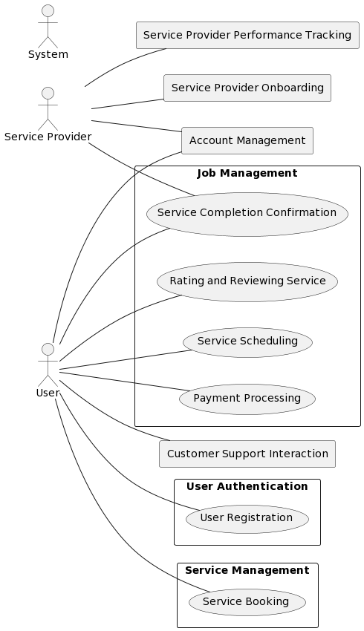

**Use Case Diagram**

### **6.2 Activity Diagrams**

### **6.3 Sequence Diagrams**

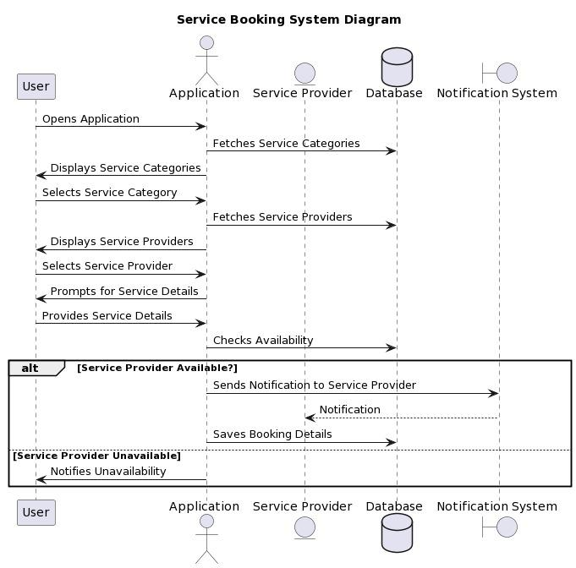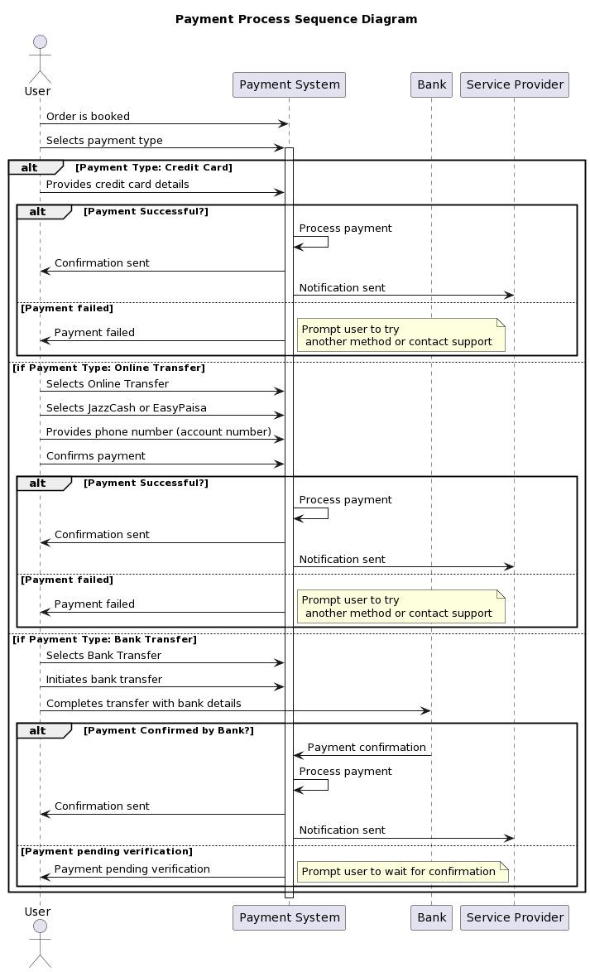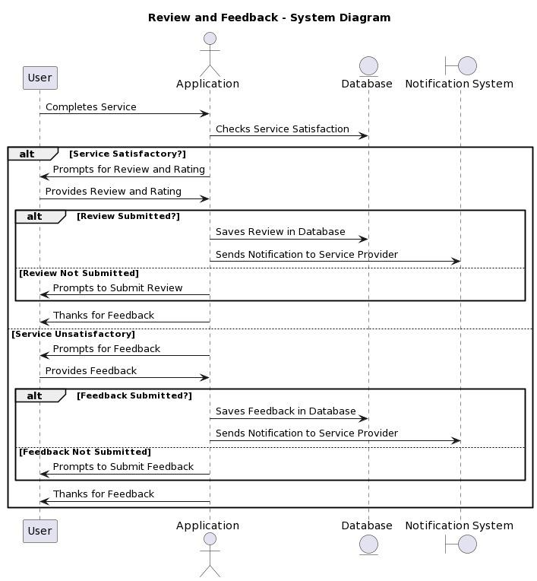

## **Appendix A: Glossary**

**Admin UI:** The interface designed for administrators to manage the HomeCarePro system, including user information, service provider approvals, and handling refunds or complaints.

**Background Checks:** Verification processes conducted on service providers to ensure the safety and reliability of homeowners, involving checks on criminal records, qualifications, and credentials.

**Billing:** The process of generating invoices for completed services and facilitating payment transactions between homeowners and service providers.

**Data Encryption:** The method of securing sensitive user data by encoding it to prevent unauthorized access or tampering.

**Geolocation Services:** Features utilizing GPS and mapping technology to provide location-based services, such as displaying nearby service providers or tracking appointments.

**Maintenance Events:** Scheduled tasks or services performed by service providers, including cleaning, repairs, or installations.

**Parallel Usage:** The ability of the system to support multiple simultaneous user sessions without degradation in performance.

**Response Time:** The duration taken by the system to respond to user actions, ensuring prompt feedback and a seamless user experience.

**Role-based Access Control:** A security measure restricting user access to system features and data based on predefined roles or permissions.

**Scalability:** The capability of the system to handle increased user traffic or data volume without compromising performance or functionality.

**Service Provider Verification:** The process of validating service providers' credentials, qualifications, and background information before onboarding them onto the platform.

**Service Quality Assurance:** Measures implemented to ensure the quality and reliability of services provided by service providers, including customer feedback mechanisms and performance tracking.

**User Authentication:** The process of verifying users' identities before granting access to the system, typically through login credentials or biometric authentication.

**Usability:** The degree to which the user interface of the system is intuitive, user-friendly, and easy to navigate for users of varying technical expertise.

**User Safety:** Ensuring the safety of users by preventing them from performing actions that could result in physical harm or damage to property through the system.

## **Appendix B: Analysis Models**

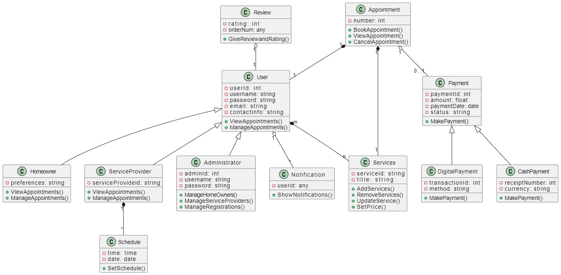

**Class Diagram**

## **Appendix C: To be Determined List**

* TBD - Performance requirements for specific functionalities.
* TBD - Detailed security protocols for user authentication.
* TBD - Entity-relationship diagram for the database schema.
* TBD - State-transition diagram for user session management.
* TBD - Specific data validation rules for user input fields.
* TBD - Business rules governing user interactions and transactions.

## **Trello Screenshots**

**Screenshot 1 of the prepare board with sprint and product backlog**

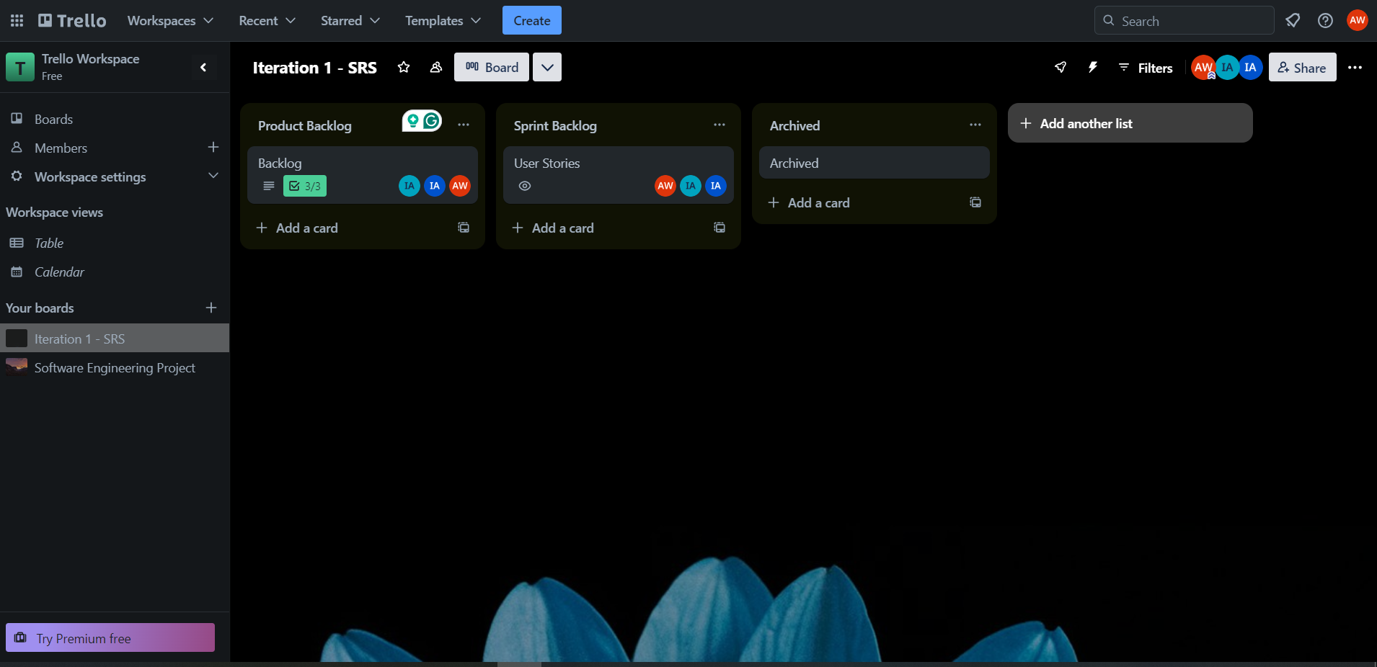

**Screenshot 2 of the user stories partially done**

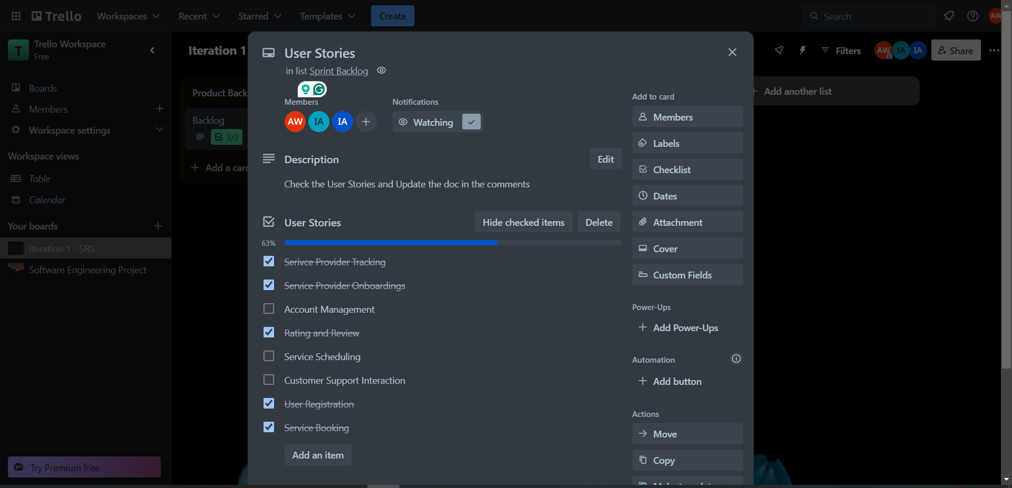

**Screenshot 3 of the Work being completely done**

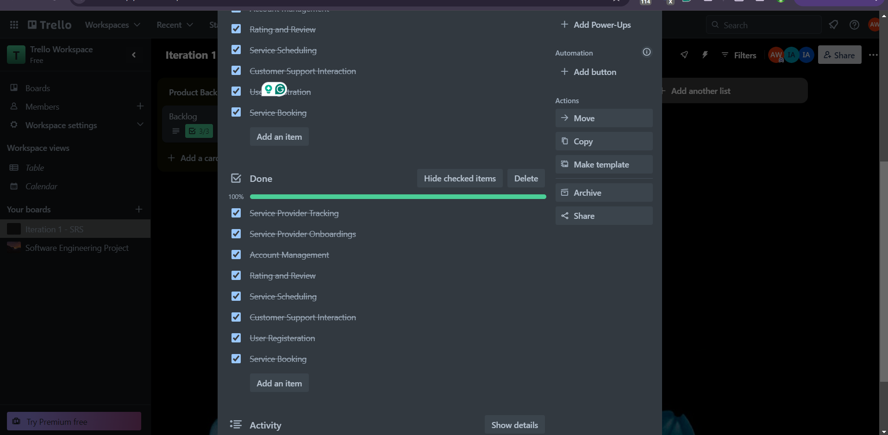

**Screenshot 4 of the activities performed by the SCRUM Master**

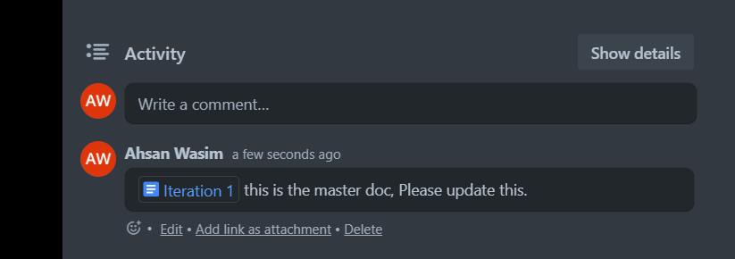

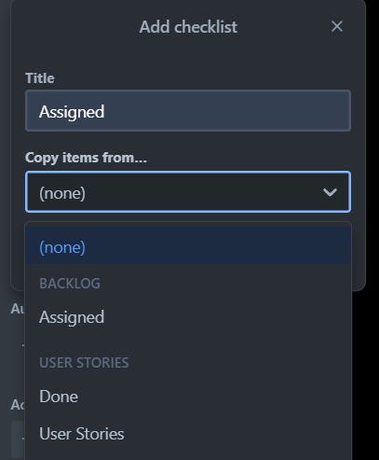

## **Github**

**Link**

<https://github.com/omaiss/Home-Care-Pro>

**Screenshot**

